AWS Global Infrastructure

* AWS Regions
* AWS Availability Zones
* AWS Data Centers
* AWS Edge Locations / Points of Presence
* [Global Infrastructure Regions & AZs (amazon.com)](https://aws.amazon.com/about-aws/global-infrastructure/regions_az/)
* [Global Infrastructure (amazon.com)](https://aws.amazon.com/about-aws/global-infrastructure/?p=ngi&loc=1)

AWS Regions

* AWS has Regions all around the world
* Names can be us-east-1, eu-west-3…
* A region is a cluster of data centers
* Most AWS services are region-scoped

How to choose an AWS Region?

* **Compliance** with data governance and legal requirements: data never leaves a region without your explicit permission
* **Proximity** to customers: reduced latency
* **Available services** within a Region: new services and new features aren’t available in every Region
* **Pricing**: pricing varies region to region and is transparent in the service pricing page

AWS Availability Zones

* Each region has many availability zones (usually 3, min is 2, max is 6).
* Example: • ap-southeast-2a • ap-southeast-2b • ap-southeast-2c • Each availability zone (AZ) is one or more discrete data centers with redundant power, networking, and connectivity
* They’re separate from each other, so that they’re isolated from disasters
* They’re connected with high bandwidth, ultra-low latency networking

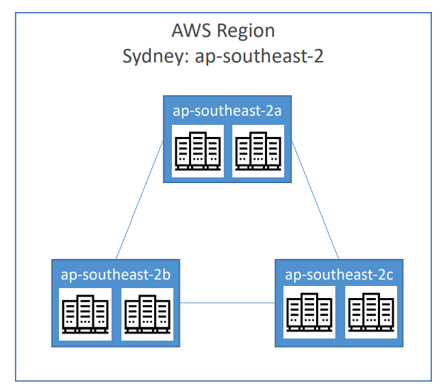

AWS Points of Presence (Edge Locations)

* Amazon has 216 Points of Presence (205 Edge Locations & 11 Regional Caches) in 84 cities across 42 countries
* Content is delivered to end users with lower latency
* [Key Features of a Content Delivery Network – Performance, Security – Amazon CloudFront](https://aws.amazon.com/cloudfront/features/?whats-new-cloudfront.sort-by=item.additionalFields.postDateTime&whats-new-cloudfront.sort-order=desc)
* <https://aws.amazon.com/about-aws/global-infrastructure/regional-product-services>

Tour of the AWS Console

* AWS has Global Services:
  + Identity and Access Management (IAM)
  + Route 53 (DNS service)
  + CloudFront (Content Delivery Network)
  + WAF (Web Application Firewall)
* Most AWS services are Region-scoped:
  + Amazon EC2 (Infrastructure as a Service)
  + Elastic Beanstalk (Platform as a Service)
  + Lambda (Function as a Service)
  + Rekognition (Software as a Service)

Shared Responsibility Model diagram

<https://aws.amazon.com/compliance/shared-responsibility-model/>

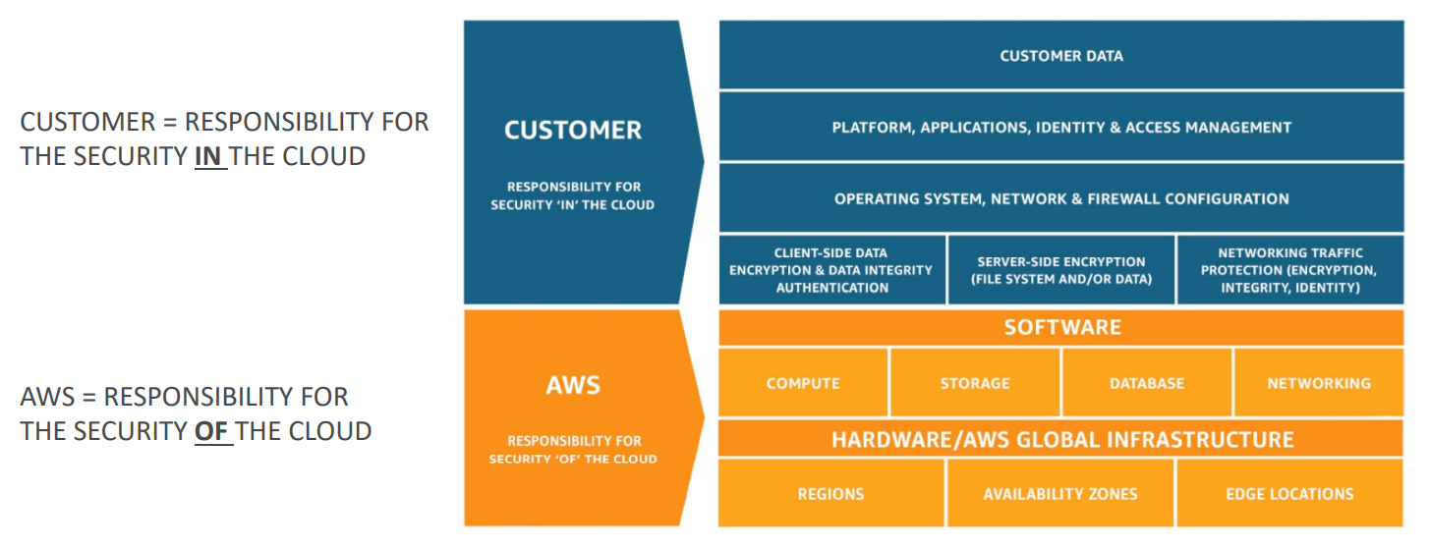

AWS Acceptable Use Policy

<https://aws.amazon.com/aup/>

IAM Section

IAM: Users & Groups

* IAM = Identity and Access Management, Global service
* Root account created by default, shouldn’t be used or shared
* Users are people within your organization, and can be grouped
* Groups only contain users, not other groups
* Users don’t have to belong to a group, and user can belong to multiple groups

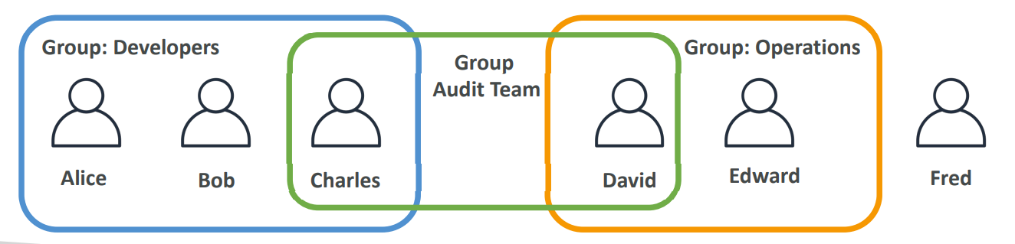

IAM Security Tools:

* IAM Credentials Report (account-level)
* a report that lists all your account's users and the status of their various credentials

IAM Access Advisor (user-level)

* Access advisor shows the service permissions granted to a user and when those services were last accessed.
* You can use this information to revise your policies.

Amazon CloudFront is a content delivery network operated by Amazon Web Services. Content delivery networks provide a globally-distributed network of proxy servers that cache content, such as web videos or other bulky media, more locally to consumers, thus improving access speed for downloading the content.

**Amazon Kinesis Video Streams** is a fully managed AWS service that you can use to stream live video from devices to the AWS Cloud, or build applications for real-time video processing or batch-oriented video analytics.

AWS Systems Manager

* Gain operational insights into AWS and on-premises resources

AWS Cost Explorer

* Visualize, understand, and manage your AWS costs and usage over time

AWS Trusted Advisor

* Reduce costs, improve performance, improve security
* Enterprise and Business Support
* AWS Trusted Advisor is another way for you to analyze your infrastructure to identify unattached, underutilized, and overutilized EBS volumes

AWS Organizations

* Centrally manage your environment as you scale your AWS resources

AWS Service Catalog

* Create, share, organize, and govern your curated IaC templates

AWS Config

* Assess, audit, and evaluate configurations of your resources

AWS CloudTrail

* Track user activity and API usage

**AWS Outposts** is a fully managed service that extends AWS infrastructure, services, APIs, and tools to customer premises. By providing local access to AWS managed infrastructure, AWS Outposts enables customers to build and run applications on premises using the same programming interfaces as in AWS Regions, while using local compute and storage resources for lower latency and local data processing needs.

Edge location

A site that CloudFront uses to cache copies of your content for faster delivery to users at any location.

**Amazon CloudFront** is a web service that speeds up distribution of your static and dynamic web content, such as .html, .css, .js, and image files, to your users. CloudFront delivers your content through a worldwide network of data centers called edge locations.

**Amazon CloudWatch** is a monitoring and observability service built for DevOps engineers, developers, site reliability engineers (SREs), IT managers, and product owners. CloudWatch provides you with data and actionable insights to monitor your applications, respond to system-wide performance changes, and optimize resource utilization. CloudWatch collects monitoring and operational data in the form of logs, metrics, and events. You get a unified view of operational health and gain complete visibility of your AWS resources, applications, and services running on AWS and on-premises.

**Amazon Inspector** is a vulnerability management service that continuously scans your AWS workloads for vulnerabilities. Amazon Inspector automatically discovers and scans Amazon EC2 instances and container images residing in Amazon Elastic Container Registry (Amazon ECR) for software vulnerabilities and unintended network exposure.

**Amazon Athena** is an interactive query service that makes it easy to analyze data in Amazon S3 using standard SQL. Athena is serverless, so there is no infrastructure to manage, and you pay only for the queries that you run.

**AWS Client VPN** is a managed client-based VPN service that enables you to securely access your AWS resources and resources in your on-premises network. With Client VPN, you can access your resources from any location using an OpenVPN-based VPN client.

A list of compute service: Amazon EC2 Amazon EC2 Auto Scaling Amazon Elastic Container Registry Amazon Elastic Container Service Amazon Elastic Kubernetes Service Amazon Lightsail AWS Batch AWS Elastic Beanstalk AWS Fargate AWS Lambda AWS Serverless Application Repository AWS Outposts VMware Cloud on AWS

AWS Security Groups

An AWS security group acts as a virtual firewall for your EC2 instances to control incoming and outgoing traffic. Both inbound and outbound rules [control the flow](https://docs.aws.amazon.com/vpc/latest/userguide/VPC_SecurityGroups.html) of traffic to and traffic from your instance, respectively.

Amazon Aurora

* Designed for unparalleled high performance and availability at global scale with full MySQL and PostgreSQL compatibility

Amazon Redshift

* Fastest, easiest, and most widely used cloud data warehouse

**Amazon Macie** is a fully managed data security and rail that uses machine learning and pattern matching to help you discover, monitor, and protect sensitive data in your AWS environment.

**AWS CloudFormation** is a service that helps you model and set up your AWS resources so that you can spend less time managing those resources and more time focusing on your applications that run in AWS.

AWS Fargate

* Serverless compute for containers

AWS Glue

* Discover, prepare, and integrate all your data at any scale

Amazon Comprehend

* Derive and understand valuable insights from text within documents

**Amazon Polly** is a service that turns text into lifelike speech, allowing you to create applications that talk, and build entirely new categories of speech-enabled products. Polly's [Text-to-Speech](https://aws.amazon.com/polly/what-is-text-to-speech/) (TTS) service uses advanced deep learning technologies to synthesize natural sounding human speech. With dozens of lifelike voices across a broad set of languages, you can build speech-enabled applications that work in many different countries.

**Amazon Kendra** is an intelligent search service powered by machine learning (ML). Kendra reimagines enterprise search for your websites and applications so your employees and customers can easily find the content they’re looking for, even when it’s scattered across multiple locations and content repositories within your organization.

AWS Snowball

* Accelerate moving offline data or remote storage to the cloud

AWS Database Migration Service

* Migrate your databases to AWS with minimal downtime.More than 650,000 databases migrated using AWS Database Migration Service

**AWS WAF** is a web application firewall that lets you monitor the HTTP(S) requests that are forwarded to your protected web application resources.

**The AWS Health Dashboard** is the single place to learn about the availability and operations of AWS services. You can view the overall status of AWS services, and you can sign in to view personalized communications about your particular AWS account or organization. Your account view provides deeper visibility into resource issues, upcoming changes, and important notifications.

**cloudtrail** reports on who made the change, when, and from which location. **aws config** reports what change to resources. AWS CloudTrail is a service that enables governance, compliance, operational auditing, and risk auditing of your AWS account. With CloudTrail, you can log, continuously monitor, and retain account activity related to actions across your AWS infrastructure. CloudTrail provides an event history of your AWS account activity, including actions taken through the AWS Management Console, AWS SDKs, command-line tools, and other AWS services. **AWS Config** provides a detailed view of the configuration of AWS resources in your AWS account. This includes how the resources are related to one another and how they were configured in the past so that you can see how the configurations and relationships change over time. AWS Config is designed to help you oversee your application resources in the following scenarios: Resource Administration, Auditing and Compliance, Managing and Troubleshooting Configuration Changes, Security Analysis. **Config** is focused on the configuration of your AWS resources and reports with detailed snapshots on how your resources have changed. Whereas CloudTrail focuses on the events or API calls, that drive those changes. It focuses on the user, application, and activity performed on the system.

**Amazon GuardDuty** - Amazon GuardDuty is a threat detection service that monitors malicious activity and unauthorized behavior to protect your AWS account. GuardDuty analyzes billions of events across your AWS accounts from AWS CloudTrail, Amazon VPC Flow Logs, and DNS Logs. Its a threat detection service and not a configuration management and tracking service.

**AWS Artifact** is your go-to, central resource for compliance-related information that matters to you. It provides on-demand access to AWS’ security and compliance reports and select online agreements.

AWS Concierge Support team - A primary point of contact for AWS Billing and AWS Support

**AWS X-Ray** is a service that collects data about requests that your application serves, and provides tools that you can use to view, filter, and gain insights into that data to identify issues and opportunities for optimization. For any traced request to your application, you can see detailed information not only about the request and response, but also about calls that your application makes to downstream AWS resources, microservices, databases, and web APIs.

X-ray = Performance Monitoring, shows a map of your application’s underlying components

AWS Wavelength enables developers to build applications that deliver ultra-low latencies to mobile devices and end users. Wavelength deploys standard AWS compute and storage services to the edge of communications service providers' (CSP) 5G networks.

AWS Systems Manager to automate database patching according to a schedule.

* VPN connection is used for secure connection between on-premises and AWS
* Internet gateway is needed when your AWS resources should be reachable from the internet –
* NAT gateway is needed when your AWS resources need access to the internet but at the same time they are not reachable from the public internet.
* A VPC endpoint enables private connections between your VPC and supported AWS services and VPC endpoint services powered by AWS PrivateLink. AWS PrivateLink is a technology that enables you to privately access services by using private IP addresses. Traffic between your VPC and the other service does not leave the Amazon network. A VPC endpoint does not require an internet gateway, virtual private gateway, NAT device, VPN connection, or AWS Direct Connect connection. Instances in your VPC do not require public IP addresses to communicate with resources in the service.
* High availability provides fault tolerance, not keeping data near costumers
* **AWS Artifact** provides on-demand downloads of AWS security and compliance documents, such as AWS ISO certifications, Payment Card Industry (PCI), and Service Organization Control (SOC) reports. You can submit the security and compliance documents (also known as audit artifacts) to your auditors or regulators to demonstrate the security and compliance of the AWS infrastructure and services that you use.
* A. On-Demand Instances
* B. Reserved Instances
* C. Spot Instances
* D. Dedicated Instances
* The **AWS Snowball service** uses physical storage devices to transfer large amounts of data between Amazon Simple Storage Service (Amazon S3) and your onsite data storage location at faster-than-internet speeds.
* AWS Snowmobile
  + Migrate or transport exabyte-scale datasets into and out of AWS
* **AWS Batch** helps you to run batch computing workloads on the AWS Cloud. Batch computing is a common way for developers, scientists, and engineers to access large amounts of compute resources. AWS Batch removes the undifferentiated heavy lifting of configuring and managing the required infrastructure, similar to traditional batch computing software.
* **AWS Migration Hub** is the one destination for cloud migration and modernization, giving you the tools you need to accelerate and simplify your journey with AWS.
* **Amazon Route 53** is a highly available and scalable Domain Name System (DNS) web service. You can use Route 53 to perform three main functions in any combination: domain registration, DNS routing, and health checking.
* **Amazon Cognito** provides authentication, authorization, and user management for your web and mobile apps. Your users can sign in directly with a user name and password, or through a third party such as Facebook, Amazon, Google or Apple.
* AWS Transit Gateway connects your Amazon Virtual Private Clouds (VPCs) and on-premises networks through a central hub. This simplifies your network and puts an end to complex peering relationships. It acts as a cloud router – each new connection is only made once.
* Amazon Kendra is a highly accurate and intelligent search service that enables your users to search unstructured and structured data using natural language processing and advanced search algorithms. It returns specific answers to questions, giving users an experience that's close to interacting with a human expert. It is highly scalable and capable of meeting performance demands, tightly integrated with other AWS services such as [Amazon S3](https://docs.aws.amazon.com/kendra/latest/dg/data-source-s3.html) and [Amazon Lex](https://docs.aws.amazon.com/lexv2/latest/dg/faq-bot-kendra-search.html), and offers enterprise-grade security.
* **AWS IAM Identity Center** (successor to AWS Single Sign-On) expands the capabilities of AWS Identity and Access Management (IAM) to provide a central place that brings together administration of users and their access to AWS accounts and cloud applications. Although the service name AWS Single Sign-On has been retired, the term single sign-on is still used throughout this guide to describe the authentication scheme that allows users to sign in one time to access multiple applications and websites.
* With **Amazon GameLift**, you can deploy, operate, and scale dedicated, low-cost servers in the cloud for session-based multiplayer games.
* Amazon Appstream 2.0 – desktops
* Amazon Workspaces – virtual desktops
* **Amazon Macie** is a fully managed data security and data privacy service that uses machine learning and pattern matching to help you discover, monitor, and protect sensitive data in your AWS environment.
* AWS Abuse addresses many different types of potentially abusive activity such as phishing, malware, spam, and denial of service (DoS)/ distributed denial of service (DDoS) incidents.
* AWS CodeStar
  + Quickly develop, build, and deploy applications on AWS
* Amazon CodeGuru
  + Automate code reviews and optimize application performance with ML-powered recommendations
* AWS CodeCommit
  + Securely host highly scalable private Git repositories. Collaborate on code
* AWS CodeDeploy
  + Automate code deployments to maintain application uptime

**Developer** - AWS recommends Developer Support plan if you are testing or doing early development on AWS and want the ability to get email-based technical support during business hours. This plan also supports general guidance on how services can be used for various use cases, workloads, or applications. You do not get access to Infrastructure Event Management with this plan.

**Enterprise** - AWS Enterprise Support provides customers with concierge-like service where the main focus is helping the customer achieve their outcomes and find success in the cloud. With Enterprise Support, you get 24x7 technical support from high-quality engineers, tools and technology to automatically manage the health of your environment, consultative architectural guidance delivered in the context of your applications and use-cases, and a designated Technical Account Manager (TAM) to coordinate access to proactive/preventative programs and AWS subject matter experts.

**Business** - AWS recommends Business Support if you have production workloads on AWS and want 24x7 phone, email and chat access to technical support and architectural guidance in the context of your specific use-cases. You get full access to AWS Trusted Advisor Best Practice Checks.

**Basic** - The basic plan only provides access to the following:

Customer Service & Communities - 24x7 access to customer service, documentation, whitepapers, and support forums. AWS Trusted Advisor - Access to the 7 core Trusted Advisor checks and guidance to provision your resources following best practices to increase performance and improve security. AWS Personal Health Dashboard - A personalized view of the health of AWS services, and alerts when your resources are impacted.

**EBS** - Amazon Elastic Block Store (EBS) is an easy to use, high-performance block storage service designed for use with Amazon Elastic Compute Cloud (EC2) for both throughput and transaction-intensive workloads at any scale. A broad range of workloads, such as relational and non-relational databases, enterprise applications, containerized applications, big data analytics engines, file systems, and media workflows are widely deployed on Amazon EBS.

**Instance Store** - An instance store provides temporary block-level storage for your EC2 instance. This storage is located on disks that are physically attached to the host computer. Instance store is ideal for the temporary storage of information that changes frequently, such as buffers, caches, scratch data, and other temporary content, or for data that is replicated across a fleet of instances, such as a load-balanced pool of web servers. Instance storage is temporary, data is lost if instance experiences failure or is terminated. EC2 instance store cannot be used for file sharing between instances.

Incorrect options:

**EFS** - Amazon Elastic File System (Amazon EFS) provides a simple, scalable, fully managed, elastic NFS file system. It is built to scale on-demand to petabytes without disrupting applications, growing and shrinking automatically as you add and remove files, eliminating the need to provision and manage capacity to accommodate growth. Amazon EFS is designed to provide massively parallel shared access to thousands of Amazon EC2 instances, enabling your applications to achieve high levels of aggregate throughput and IOPS with consistent low latencies.

**S3** - Amazon Simple Storage Service (Amazon S3) is an object storage service that offers industry-leading scalability, data availability, security, and performance. This means customers of all sizes and industries can use it to store and protect any amount of data for a range of use cases, such as websites, mobile applications, backup and restore, archive, enterprise applications, IoT devices, and big data analytics.

**ECS** - Amazon Elastic Container Service (ECS) is a highly scalable, high-performance container management service that supports Docker containers and allows you to easily run applications on a managed cluster of Amazon EC2 instances. This is not a storage service and has been added as a distractor

The AWS Cost and Usage Reports (AWS CUR) contains the most comprehensive set of cost and usage data available. You can use Cost and Usage Reports to publish your AWS billing reports to an Amazon Simple Storage Service (Amazon S3) bucket that you own. You can receive reports that break down your costs by the hour or month, by product or product resource, or by tags that you define yourself. AWS updates the report in your bucket once a day in comma-separated value (CSV) format. **AWS Pricing Calculator** - AWS Pricing Calculator lets you explore AWS services and create an estimate for the cost of your use cases on AWS. You can model your solutions before building them, explore the price points and calculations behind your estimate, and find the available instance types and contract terms that meet your needs. This enables you to make informed decisions about using AWS. You can plan your AWS costs and usage or price out setting up a new set of instances and services.

**AWS Cost Explorer** - AWS Cost Explorer has an easy-to-use interface that lets you visualize, understand, and manage your AWS costs and usage over time. AWS Cost Explorer includes a default report that helps you visualize the costs and usage associated with your top five cost-accruing AWS services, and gives you a detailed breakdown of all services in the table view. The reports let you adjust the time range to view historical data going back up to twelve months to gain an understanding of your cost trends. AWS Cost Explorer cannot provide a detailed report of your AWS costs by the hour into an S3 bucket.

**AWS Budgets** - AWS Budgets gives the ability to set custom budgets that alert you when your costs or usage exceed (or are forecasted to exceed) your budgeted amount. You can also use AWS Budgets to set reservation utilization or coverage targets and receive alerts when your utilization drops below the threshold you define. Budgets can be created at the monthly, quarterly, or yearly level, and you can customize the start and end dates. You can further refine your budget to track costs associated with multiple dimensions, such as AWS service, linked account, tag, and others. AWS Budgets cannot provide the estimate of the monthly AWS bill based on the list of AWS services. AWS Budgets cannot provide a detailed break down of your AWS costs by the hour.

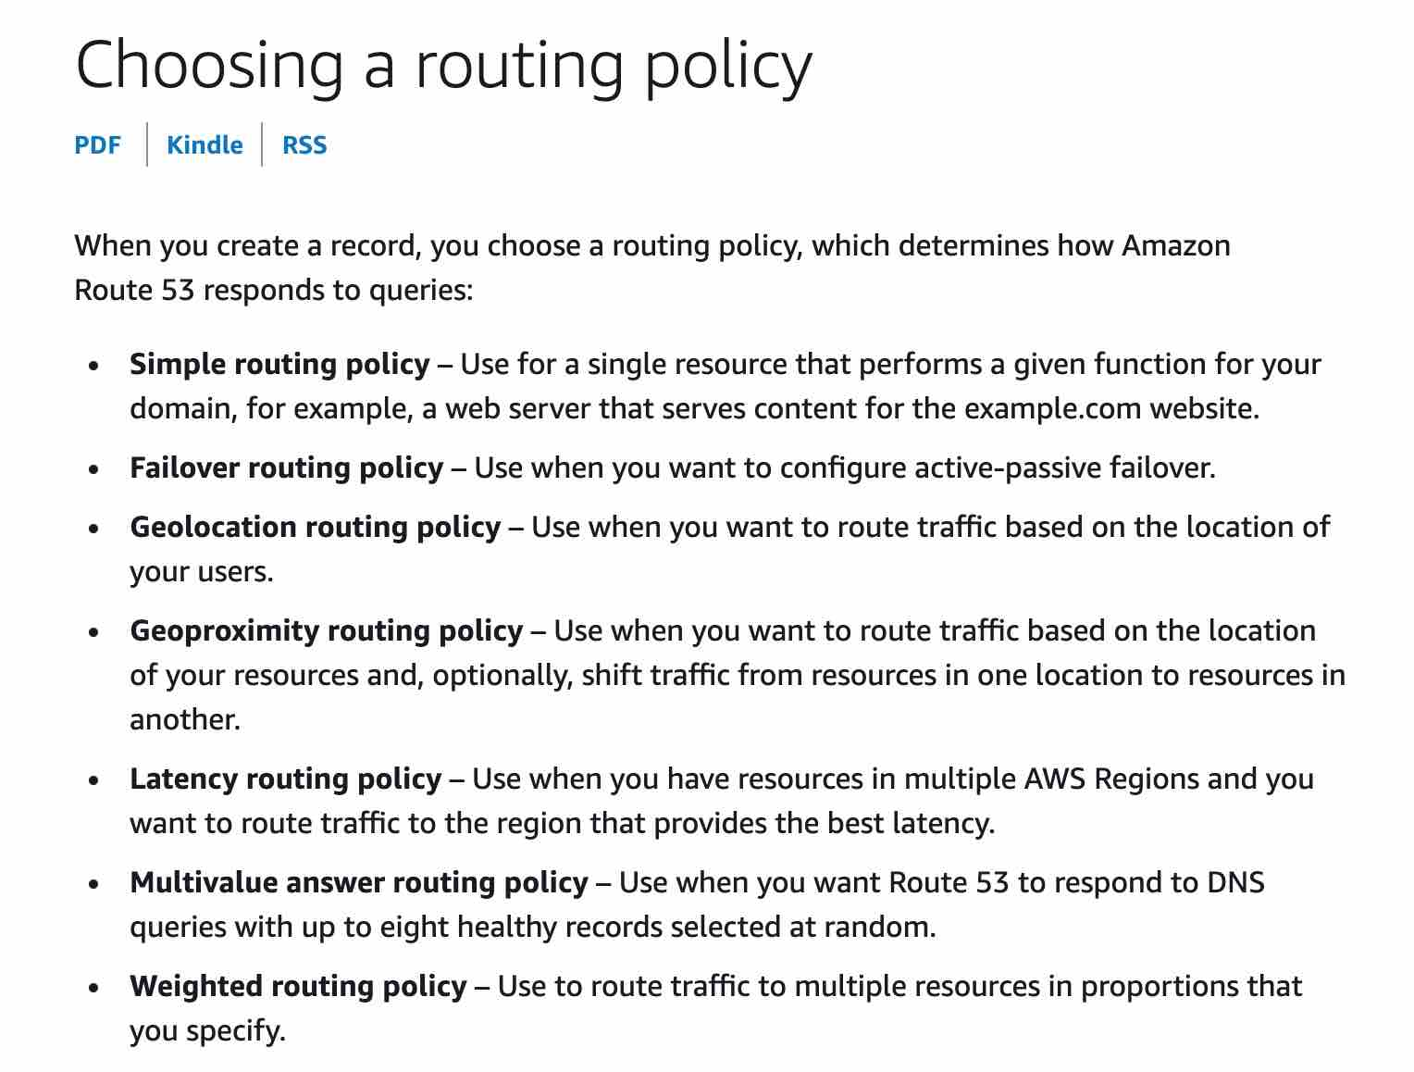

AWS Cost and usage Reports

AWS CloudWatch

AWS budgets

Flexible application – Spot instance

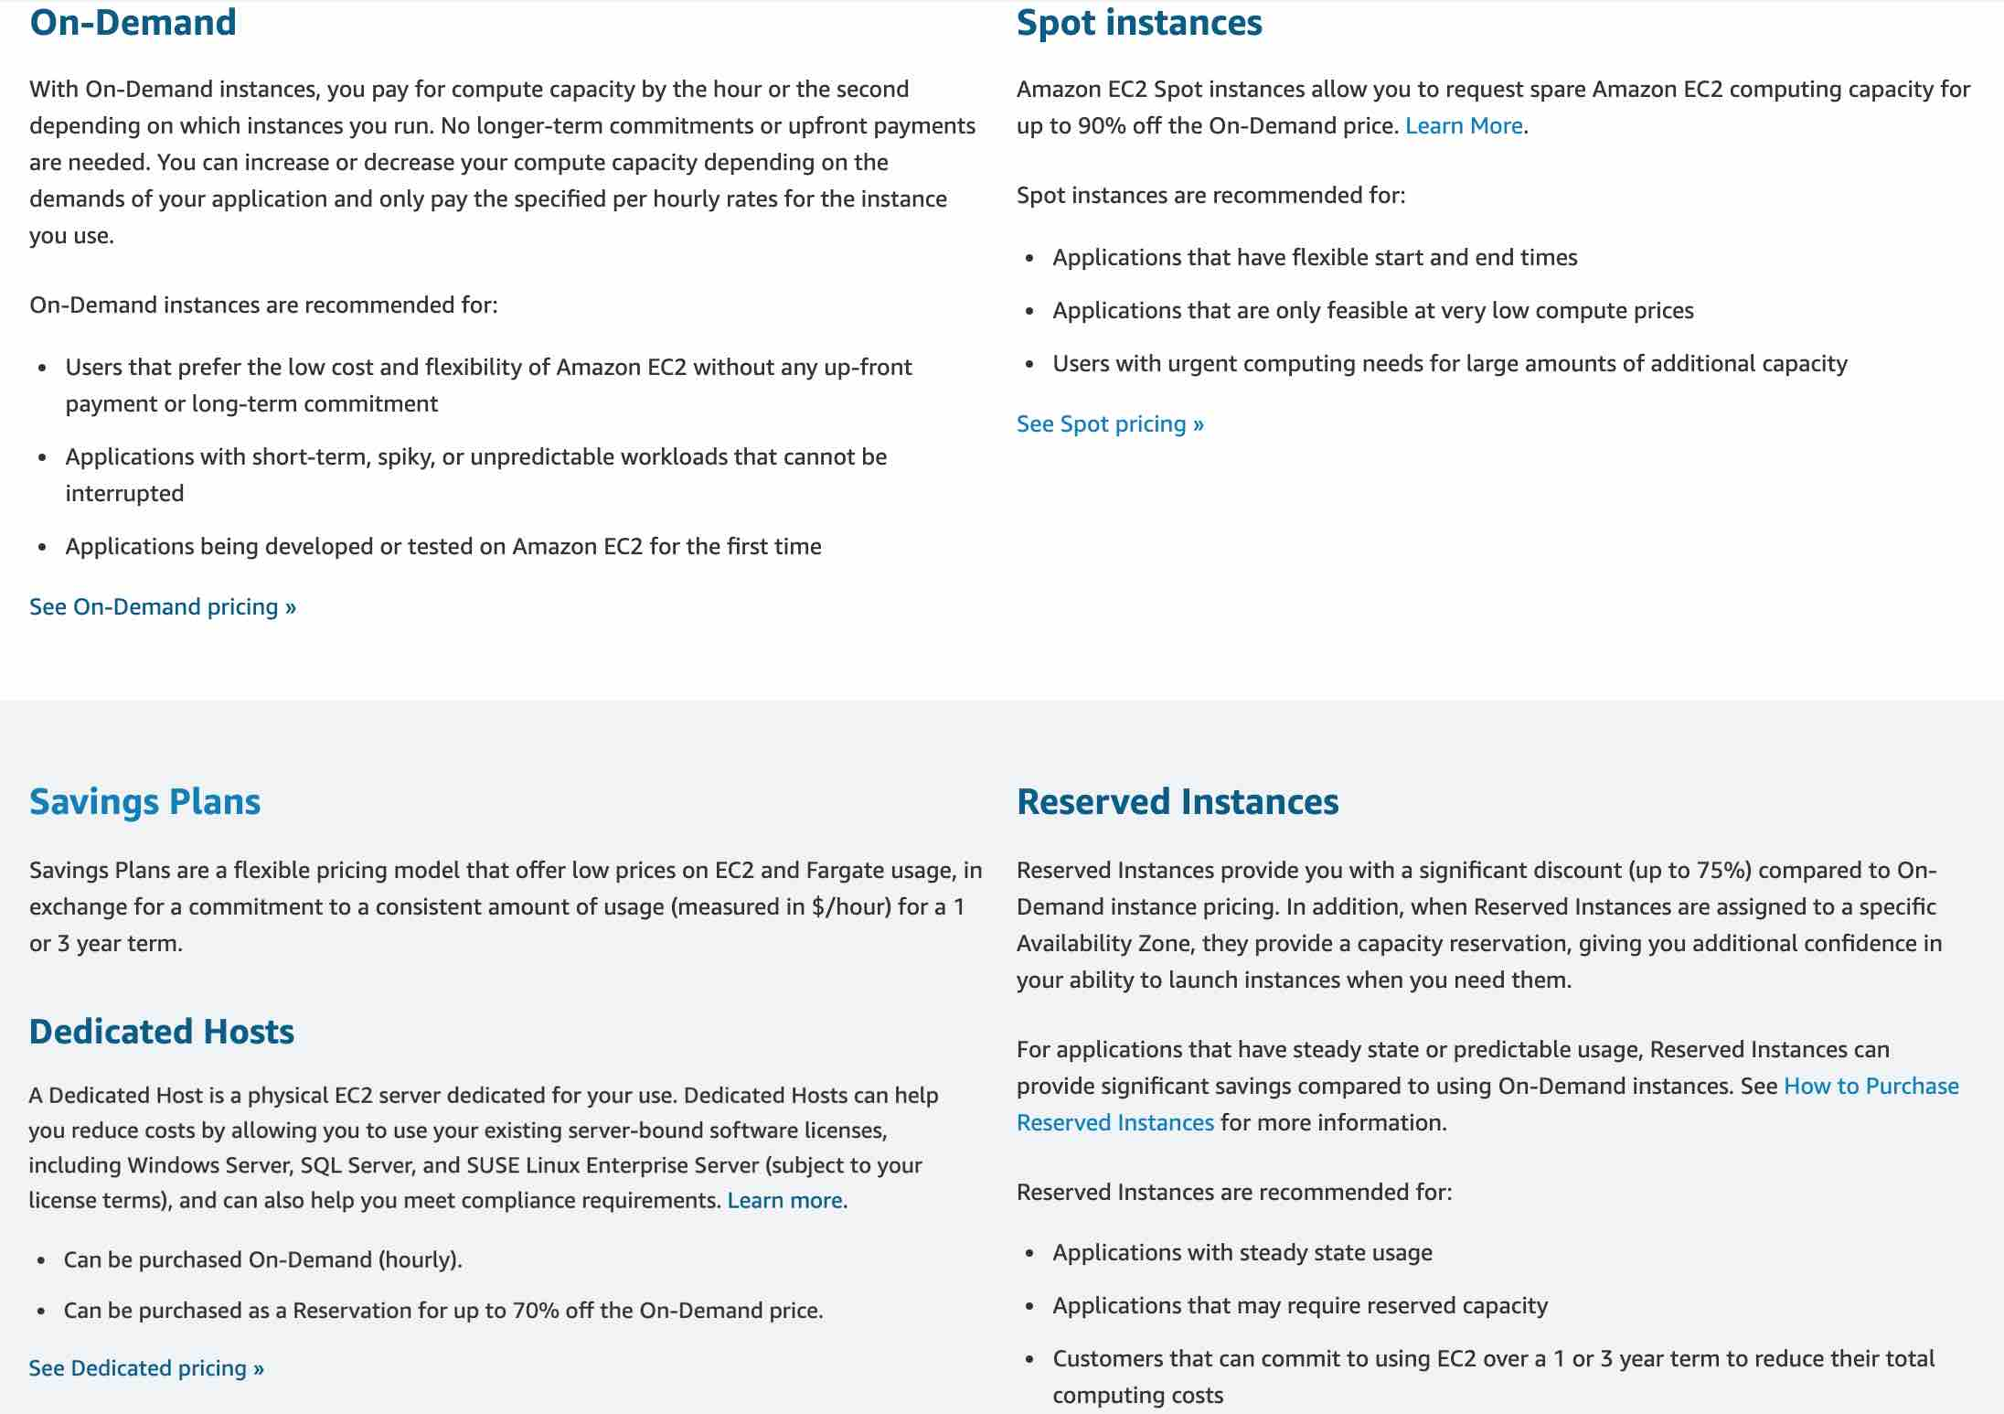

**Dedicated Host** - Amazon EC2 Dedicated Hosts allow you to use your eligible software licenses from vendors such as Microsoft and Oracle on Amazon EC2 so that you get the flexibility and cost-effectiveness of using your licenses, but with the resiliency, simplicity, and elasticity of AWS. An Amazon EC2 Dedicated Host is a physical server fully dedicated for your use, so you can help address corporate compliance requirement. They're not cost-efficient compared to spot instances.

**AWS Transit Gateway**

AWS Transit Gateway connects VPCs and on-premises networks through a central hub. This simplifies your network and puts an end to complex peering relationships. It acts as a cloud router – each new connection is only made once. As you expand globally, inter-Region peering connects AWS Transit Gateways using the AWS global network. Your data is automatically encrypted and never travels over the public internet.

**VPC Peering** - A VPC peering connection is a networking connection between two VPCs that enables you to route traffic between them privately. VPC peering is not transitive, a separate VPC peering connection has to be made between two VPCs that need to talk to each other. With growing VPCs, this gets difficult to manage.

**Site to Site VPN** - AWS Site-to-Site VPN creates a secure connection between your data center or branch office and your AWS cloud resources. This connection goes over the public internet. Site to Site VPN cannot be used to interconnect VPCs.

**S3 Glacier** - Amazon S3 Glacier is a secure, durable, and extremely low-cost Amazon S3 cloud storage class for data archiving and long-term backup. It is designed to deliver 99.999999999% durability, and provide comprehensive security and compliance capabilities that can help meet even the most stringent regulatory requirements.

**S3 One Zone-IA**

S3 One Zone-IA is for data that is accessed less frequently but requires rapid access when needed. Unlike other S3 Storage Classes which store data in a minimum of three Availability Zones (AZs), S3 One Zone-IA stores data in a single AZ.

**S3 Standard** - S3 Standard offers high durability, availability, and performance object storage for frequently accessed data. It is not suitable for data archival.

**S3 Intelligent-Tiering** - The S3 Intelligent-Tiering storage class is designed to optimize costs by automatically moving data to the most cost-effective access tier, without performance impact or operational overhead. It works by storing objects in two access tiers: one tier that is optimized for frequent access and another lower-cost tier that is optimized for infrequent access. It is not suitable for data archival.

**S3 One Zone-IA** - S3 One Zone-IA is for data that is accessed less frequently, but requires rapid access when needed. Unlike other S3 Storage Classes which store data in a minimum of three Availability Zones (AZs), S3 One Zone-IA stores data in a single AZ. It is not suitable for data archival.

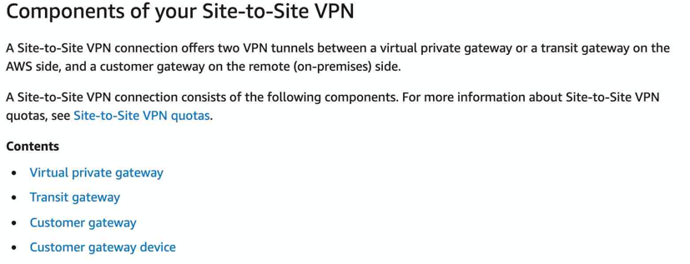

72

**AWS CloudFormation** - AWS CloudFormation allows you to use programming languages or a simple text file to model and provision, in an automated and secure manner, all the resources needed for your applications across all regions and accounts. It cannot be used to automate code deployment.

**AWS Service Health Dashboard** - Amazon Web Services publishes up-to-the-minute information on service availability in a tabular form through its Service Health Dashboard page. You can check the page any time to get current status information or subscribe to an RSS feed to be notified of interruptions to each service. The page can be accessed via the URL - <https://status.aws.amazon.com/>.

**AWS Migration Evaluator**

Migration Evaluator (Formerly TSO Logic) is a complimentary service to create data-driven business cases for AWS Cloud planning and migration.

Migration Evaluator quickly provides a business case to make sound AWS planning and migration decisions. With Migration Evaluator, your organization can build a data-driven business case for AWS, gets access to AWS expertise, visibility into the costs associated with multiple migration strategies, and insights on how reusing existing software licensing reduces costs further.

**AWS Billing and Cost Management** - AWS Billing and Cost Management is the service that you use to pay your AWS bill, monitor your usage, and analyze and control your costs. It is the billing department for AWS services - with necessary tools and services under its hood. You cannot use this service to create data-driven business cases for transitioning your business from on-premises to AWS Cloud.

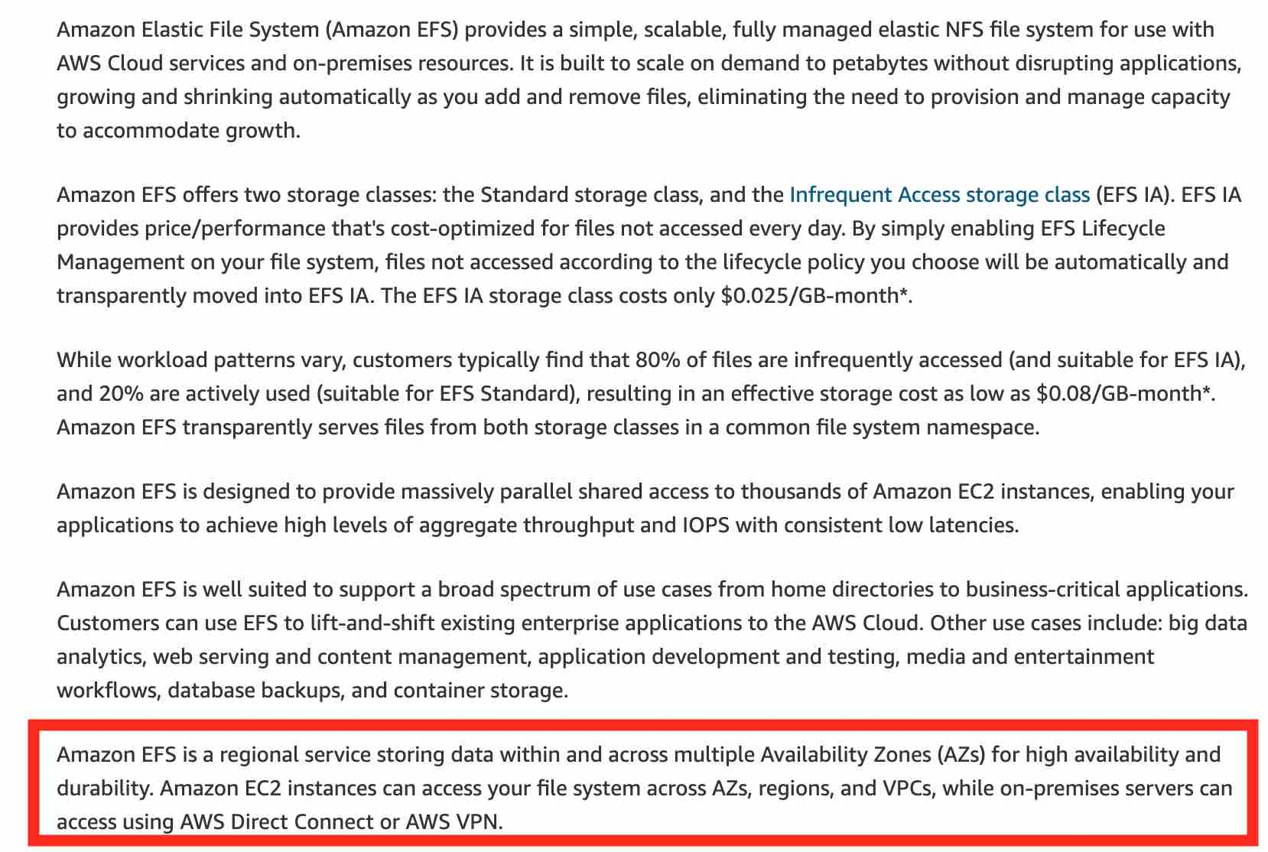s

**AWS Storage Gateway** - AWS Storage Gateway is a hybrid cloud storage service that gives you on-premises access to virtually unlimited cloud storage. All data transferred between the gateway and AWS storage is encrypted using SSL (for all three types of gateways - File, Volume and Tape Gateways).

**US East (N. Virginia) - us-east-1**

You can monitor your estimated AWS charges by using Amazon CloudWatch. Billing metric data is stored in the US East (N. Virginia) Region and represents worldwide charges. This data includes the estimated charges for every service in AWS that you use, in addition to the estimated overall total of your AWS charges.

**Penetration Testing**

AWS customers can carry out security assessments or penetration tests against their AWS infrastructure without prior approval for few common AWS services. Customers are not permitted to conduct any security assessments of AWS infrastructure, or the AWS services themselves.

Incorrect options:

**Network Stress Testing** - AWS considers "network stress test" to be when a test sends a large volume of legitimate or test traffic to a specific intended target application. The endpoint and infrastructure are expected to be able to handle this traffic.

**Amazon Inspector** - Amazon Inspector is an automated, security assessment service that helps you check for unintended network accessibility of your Amazon EC2 instances and for vulnerabilities on those EC2 instances. Amazon Inspector assessments are offered to you as pre-defined rules packages mapped to common security best practices and vulnerability definitions.

**AWS Secrets Manager** - AWS Secrets Manager helps you protect secrets needed to access your applications, services, and IT resources. The service enables you to easily rotate, manage, and retrieve database credentials, API keys, and other secrets throughout their lifecycle. Users and applications retrieve secrets with a call to Secrets Manager APIs, eliminating the need to hardcode sensitive information in plain text.

\

* Cost Budget
* Reservation budget
* Usage Budget

Amazon Comprehend

* Derive and understand valuable insights from text within documents

Amazon Lex

* Build chatbots with conversational AI
* **VPN connection** is used for secure connection between on-premises and AWS
* **Internet gateway** is needed when your AWS resources should be reachable from the internet
* **NAT gateway** is needed when your AWS resources need access to the internet but at the same time they are not reachable from the public internet.
* **VPC endpoint**: A VPC endpoint enables private connections between your VPC and supported AWS services and VPC endpoint services powered by AWS PrivateLink. AWS PrivateLink is a technology that enables you to privately access services by using private IP addresses. Traffic between your VPC and the other service does not leave the Amazon network. A VPC endpoint does not require an internet gateway, virtual private gateway, NAT device, VPN connection, or AWS Direct Connect connection. Instances in your VPC do not require public IP addresses to communicate with resources in the service.
* **AWS CodeStar** - AWS CodeStar is a cloud‑based development service that provides the tools you need to quickly develop, build, and deploy applications on AWS.
* **Amazon Transcribe** - Amazon Transcribe makes it easy for developers to add speech to text capabilities to their applications. Audio data is virtually impossible for computers to search and analyze. Therefore, recorded speech needs to be converted to text before it can be used in applications.
* **AWS Glue** - AWS Glue is a serverless data integration service that makes it easy to discover, prepare, and combine data for analytics, machine learning, and application development. AWS Glue provides all of the capabilities needed for data integration, so you can start analyzing your data and putting it to use in minutes instead of months.
* **Amazon Neptune** - A graph database’s purpose is to make it easy to build and run applications that work with highly connected datasets. Typical use cases for a graph database include social networking, recommendation engines, fraud detection, and knowledge graphs. Amazon Neptune is a fully-managed graph database service and it's also considered as a type of NoSQL database.
* **AWS IoT Core** - AWS IoT Core lets you connect IoT devices to the AWS cloud without the need to provision or manage servers. AWS IoT Core can support billions of devices and trillions of messages and can process and route those messages to AWS endpoints and to other devices reliably and securely. With AWS IoT Core, your applications can keep track of and communicate with all your devices, all the time, even when they aren’t connected.
* **Amazon Connect** - Amazon Connect is an easy to use omnichannel cloud contact center that helps you provide superior customer service at a lower cost.
* **AWS Control Tower** - AWS Control Tower provides the easiest way to set up and govern a new, secure, multi-account AWS environment based on best practices established through AWS’ experience working with thousands of enterprises as they move to the cloud. Control Tower provides mandatory and strongly recommended high-level rules, called guardrails, that help enforce your policies using service control policies (SCPs), or detect policy violations using AWS Config rules.
* **AWS Transfer Family** - The AWS Transfer Family is the aggregated name of AWS Transfer for SFTP, AWS Transfer for FTPS, and AWS Transfer for FTP. The AWS Transfer Family offers fully managed support for the transfer of files over SFTP, FTPS, and FTP directly into and out of Amazon S3 or Amazon EFS.
* **AWS OpsWorks** - AWS OpsWorks is a configuration management service that provides managed instances of Chef and Puppet. Chef and Puppet are automation platforms that allow you to use code to automate the configurations of your servers. OpsWorks lets you use Chef and Puppet to automate how servers are configured, deployed, and managed across your Amazon EC2 instances or on-premises compute environments.
* **AWS OpsHub** - AWS OpsHub is a graphical user interface you can use to manage your AWS Snowball devices, enabling you to rapidly deploy edge computing workloads and simplify data migration to the cloud.
* **AWS CloudTrail Insights** - AWS CloudTrail Insights helps AWS users identify and respond to unusual activity associated with write API calls by continuously analyzing CloudTrail management events.
* **Amazon Sumerian** - Amazon Sumerian is a managed service that lets you create and run 3D, Augmented Reality (AR) and Virtual Reality (VR) applications. You can build immersive and interactive scenes that run on AR and VR, mobile devices, and your web browser. Whether you are non-technical, a web or mobile developer, or have years of 3D development experience, getting started with Sumerian is easy.
* 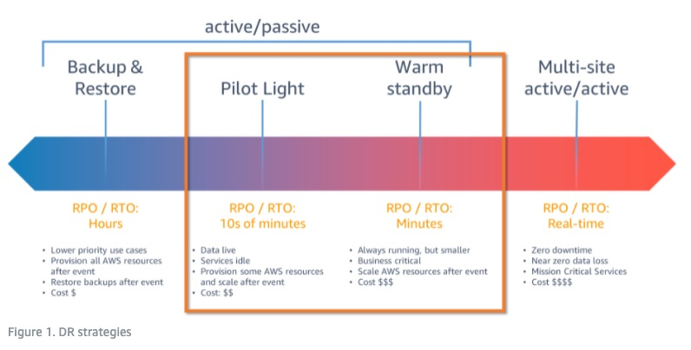
* **Amazon Kinesis data stream** - Amazon Kinesis Data Streams enables you to build custom applications that process or analyze streaming data for specialized needs.
* **AWS Snowcone** - AWS Snowcone is the smallest member of the AWS Snow Family of edge computing, edge storage, and data transfer devices, weighing in at 4.5 pounds (2.1 kg) with 8 terabytes of usable storage. Snowcone is ruggedized, secure, and purpose-built for use outside of a traditional data center. Its small form factor makes it a perfect fit for tight spaces or where portability is a necessity and network connectivity is unreliable. You can use Snowcone in backpacks on first responders, or for IoT, vehicular, and drone use cases.
* 